How to upload document in client track
Step 1
Go to the client work space
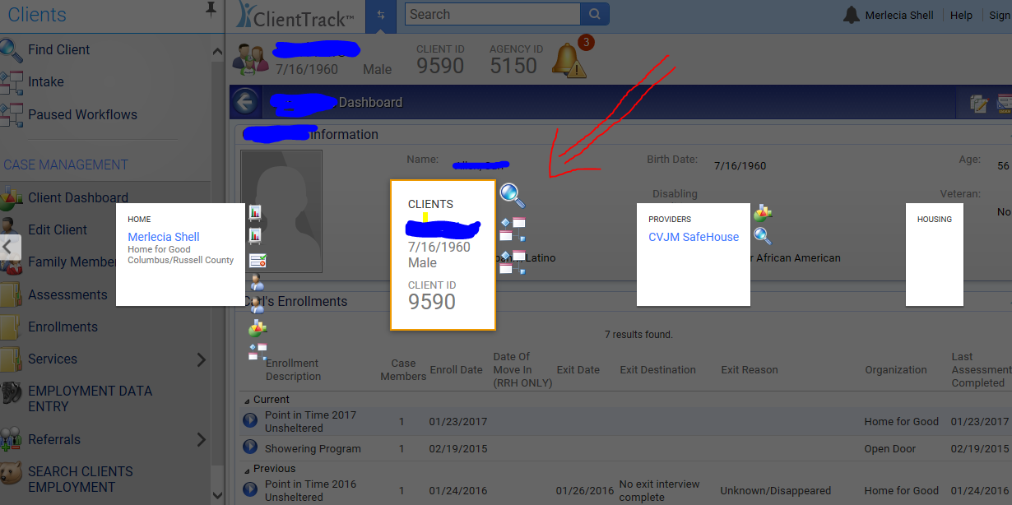
Step 2
Select client files tab
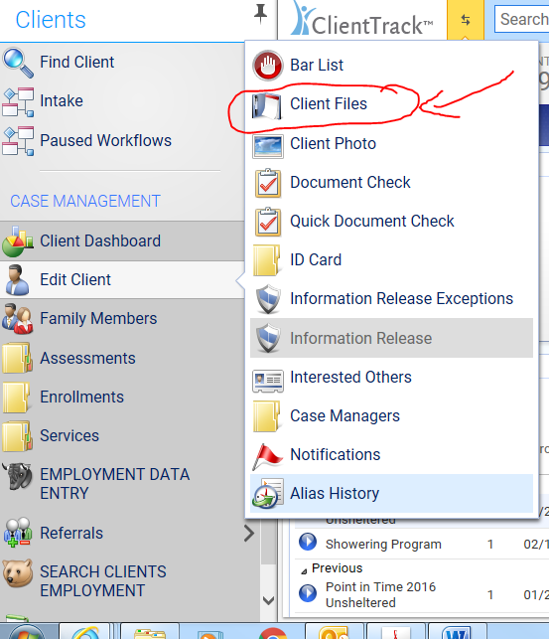
Step 3
Select the Add file button at the top right corner
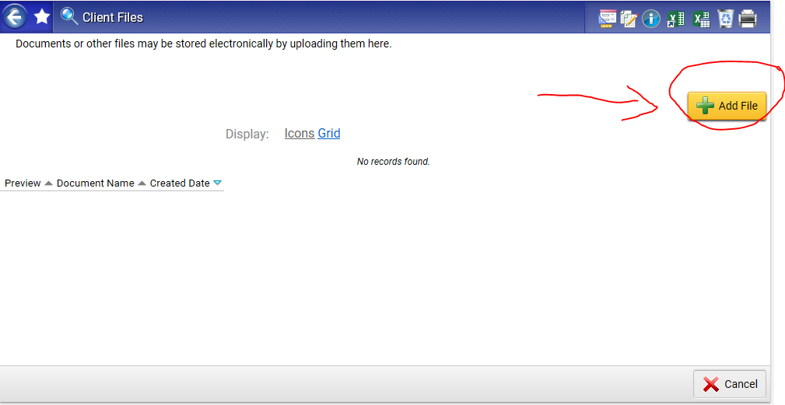

Step 4
Upload Files from your computer
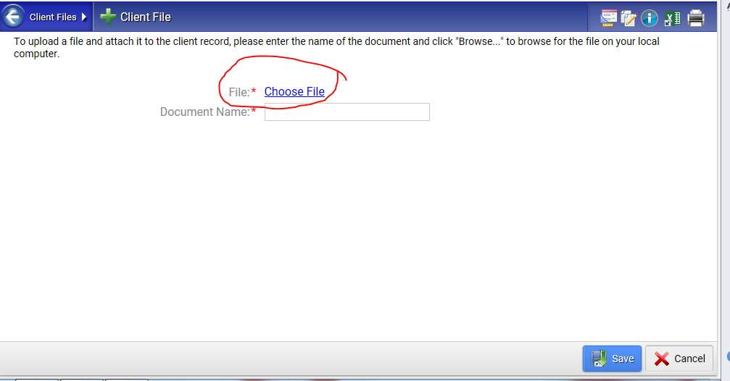

Step 5
Preview the file befor submitting.
Make sure it is clear and readable.
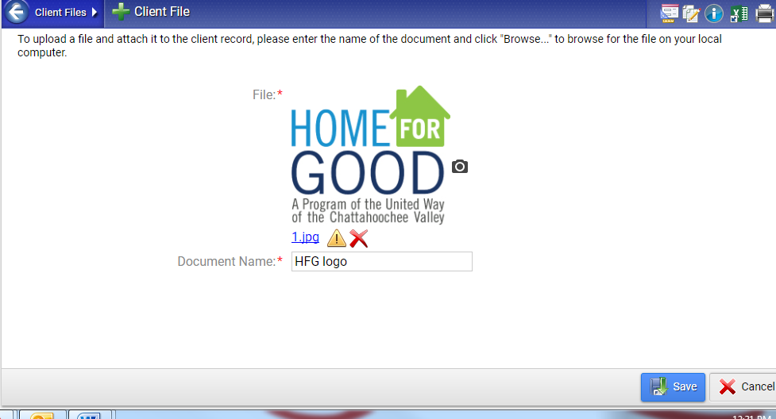
Step 6
Yay! You have uploaded the file.
